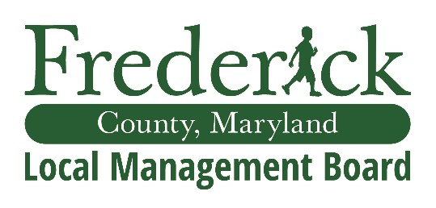
Local Management Board

March 24, 2025, | 2:00pm – 4:00pm
Department of Social Services | 1888 N Market St, Frederick, MD 21701

AGENDA

    - Call to Order
    - Welcome/Attendance – Jay Hessler | 3 – 4 mins
    - Approval of the Minutes | 1 min
    - Presentation: Presentation
a. b. FY26 CCIF NOFA Presentation – Leshia Chandler, Dr. Jenni Liveoak
      - Big Brothers Big Sisters – Kent Sneed Presentation
      - Options for Program Renewals/ New Programs Funded
      - Virtual Vote Date/Time
    - Comments and Announcements
    - Public Comments
    - Adjournment

Next Meeting Dates
- April 21, 2025
- July 28, 2025
- September 22, 2025

Frederick County Government does not discriminate on the basis of race, color, religion, national origin, sex, age, marital status, disability, familial status, gender identity, sexual orientation or source of income.

All Frederick County Boards and Commissions are subject to:
1) the Open Meetings Act requiring reasonable advance notice of meetings be provided, to make the agenda available in advance, to hold meetings openly, and to adopt and retain minutes; and
2) the Public Information Act, meaning any member of the public may request any record pertaining to the work group at any time.

