Commission Members Kyle Bostian, Dylan Diggs, John Distel, Flor Garay, Mark Jafari, Bud Otis, James Racheff, Ryan Yamagata, and Blaine Young, Jr. were present for the meeting.

Also present at the meeting were Ragen Cherney, Chief of Staff, County Council; Bryon Black, County Attorney; MC Keegan-Ayer, President, County Council; Stuart Harvey, Director, Frederick County Board of Elections; Nancy Luna, Executive Assistant, County Council; and Sarah Grabowski, Executive Assistant, County Council.

Ragen Cherney called the meeting to order at 7:00 p.m. at Winchester Hall.

All present recited the Pledge of Allegiance.

Welcome
Council President MC Keegan-Ayer welcomed the Commission Members and thanked them for their service to the county. The Council President briefly described the work they will be doing and its importance to the community.

Role of Redistricting Commission and Legal Requirements
County Attorney Bryon Black addressed the Commission Members, explaining the Open Meetings Act and Public Information Act. Mr. Black explained the legal requirements of the Commission and the corresponding sections of the County Charter that outline the duties of the Commission. The Commission must adhere to a strict timeline dictated by the Charter. Mr. Black offered to answer any questions that the Commission may have during the meeting or at any point in the future.

Frederick County Elections
Stuart Harvey addressed the Commission and presented an overview of the Frederick County Elections Board and elections process. Mr. Stuart described the districts, precincts, and polling places in the County and introduced the Commission to the Election Board Members.

Election of Commission Officers
•Mr. Racheff was nominated to be Chair of the Commission. The members voted unanimously in favor.
•Mr. Otis was nominated to serve as Vice-Chair of the Commission. The members voted 8-0-1 with Mr. Otis abstaining.

Discussion
•Mr. Cherney will be in contact with the Members about possible dates for future meetings. The Commission will be awaiting data from the 2020 Census before any substantial work can be accomplished. Because of this, the Commission will be on a restricted timeline to complete their work. The calendar will be set at the next meeting.
•The Commission will present their Report to the Council on November 9. The Council will the discuss and vote on the report in the following weeks.

Public Comment
None.

Adjourn

The meeting adjourned at 8:15 p.m.

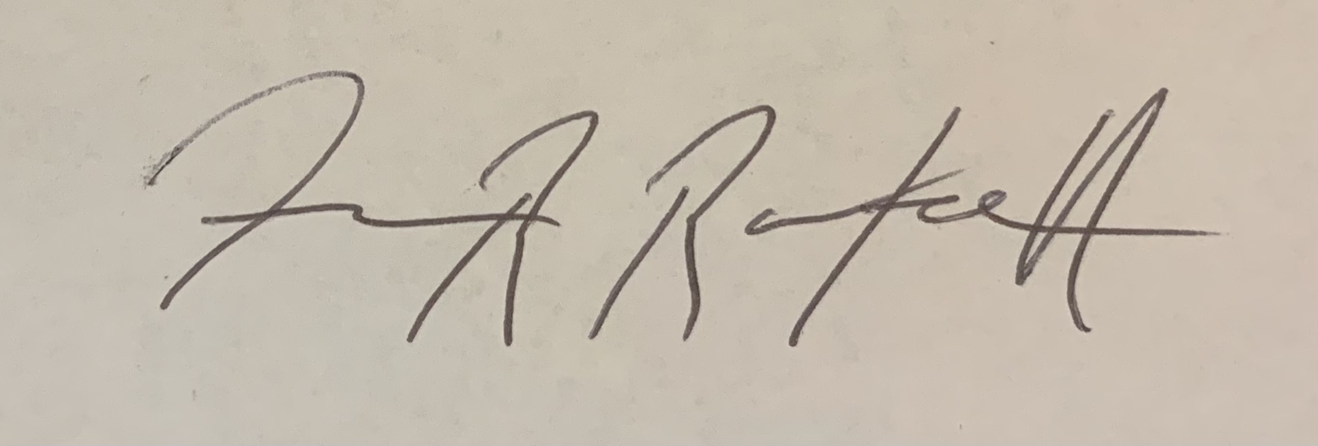

James Racheff, Chair

