Commission Members Kyle Bostian, Dylan Diggs, John Distel, Mark Jafari, Bud Otis, James Racheff, Ryan Yamagata, and Blaine Young, Jr. were present for the meeting. Commission member Flor Garay was absent.

Also present at the meeting were Ragen Cherney, Chief of Staff, County Council; Bryon Black, County Attorney; Catherine Keller, Assistant County Attorney; Dial Keju and Denis Superczynski, Planning and Permitting Division; Nancy Luna, Executive Assistant, County Council; and Sarah Grabowski, Executive Assistant, County Council.

Chair Racheff called the meeting to order at 7:00 p.m. at Winchester Hall.

All present recited the Pledge of Allegiance.

Approval of Minutes
The Commission Members voted to approve the Minutes from the June 30, 2021 meeting as written. The Minutes were approved 8-0 (with Ms. Garay being absent).

Presentation on Population Growth and Demographics in Frederick County
Mr. Dial Keju and Mr. Denis Superczynski presented the Commission with an overview of the population growth in Frederick County since 2000. The presentation included data from the 2000 and 2010 census results. As soon as the 2020 Census data becomes available, this information will be presented to the Commission.

Discussion of Timeline for the Commission
Ms. Keller provided a timeline for the Commission to complete its charge based on when the Census Bureau will provide the necessary data and when the Resolution establishing the Commission dictates that the Commission must complete its charge.

Scheduling of Future Meetings
The Commission agreed to meet on September 27, October 21, and October 25. The Commission also agreed to meet during the first week of October. This exact date will be decided in the coming weeks.

Adjourn

The meeting adjourned at 8:10 p.m.

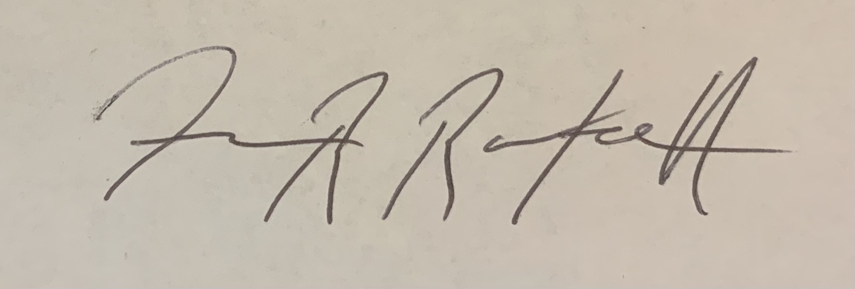

James Racheff, Chair

