Commission Members Kyle Bostian, Dylan Diggs, Flor Garay, Mark Jafari, Bud Otis, James Racheff, Ryan Yamagata, and Blaine Young, Jr. were present for the meeting. Commission member John Distel was absent.

Also present at the meeting were Ragen Cherney, Chief of Staff, County Council; Mark Welch, Election Program Assistant, Frederick County Board of Elections; Barbara Wagner, Interim Director, Frederick County Board of Elections; Catherine Keller, Assistant County Attorney; and Sarah Grabowski, Executive Assistant, County Council.

Chair Racheff called the meeting to order at 7:00 p.m. at Winchester Hall.

All present recited the Pledge of Allegiance.

Approval of Minutes
The Commission Members voted to approve the Minutes from the August 30, 2021 meeting as written. The Minutes were approved 7-0 (with Ms. Garay and Mr. Distel being absent for the vote).

Overview of the Redistricting Commissions’ Charge
Catherine Keller, Assistant County Attorney, provided the Commission with an overview of their charge and responsibilities. The County’s Charter dictates that a Redistricting Commission be established after each decennial Census. The Commission’s charge is to look at the County Council Districts and see what, if any, redistricting is appropriate. With five (5) Council Districts, we strive to have each District contain roughly 20% of the County’s population (with a difference of no more than 5% of the total County population). The Districts should be compact, contiguous, substantially equal in population, and have common interests as a result of geography, occupation, history, and existing political boundaries.

The Commission’s report (recommendation) needs to be submitted to the County Council by November 9, 2021. The presentation to the Council will occur on November 16, 2021, and at that time the Council has 30 days to hold a public hearing on the report. After the public hearing, the Council has 90 days to vote on the recommendation.

Discussion of the Final Census Data in Relation to Current Council Member District Boundaries
Ms. Wagner provided a recommendation for the Commission to take two precincts from District 2 and move them to District 5. This would take population from the highest populated District and move it to the lowest populated District. The result of this move would bring the populations of the 5 District within 1% of each other (percent of total County population).

Discussion
The Commission Members considered a few other options and the benefits of this option.
Ms. Garay requested information to support the move of the two precincts from District 2 to District 5 (regarding similar interests and culture).
Bud Otis moved that the Commission accept the Board of Elections’ recommendations, seconded by Mark Jafari. The Commission voted 5-3 in favor of accepting the recommendation.
Ms. Keller clarified that this motion could be revisited at the next meeting.
Chair Racheff and Mr. Cherney clarified how the Commission can accept public comment or communication from the public. Mr. Cherney stated that if the Commission votes on a recommendation at the next meeting (Oct 7), then the public hearing would be scheduled for the next subsequent meeting (Oct 21). The public hearing would be advertised and the public would be able to call in to the meeting.

Scheduling of Future Meetings
The Commission agreed to meet on October 7 (7pm), October 21, and October 25. Monday November 1 is another possible meeting date should the Commission need it.

Adjourn

The meeting adjourned at 8:00 p.m.

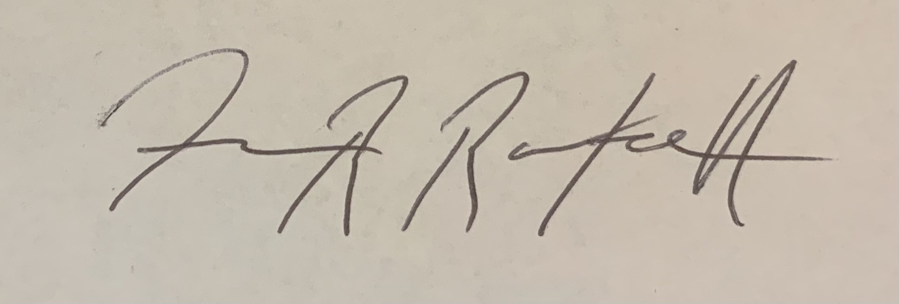

(Approved) James Racheff, Chair

