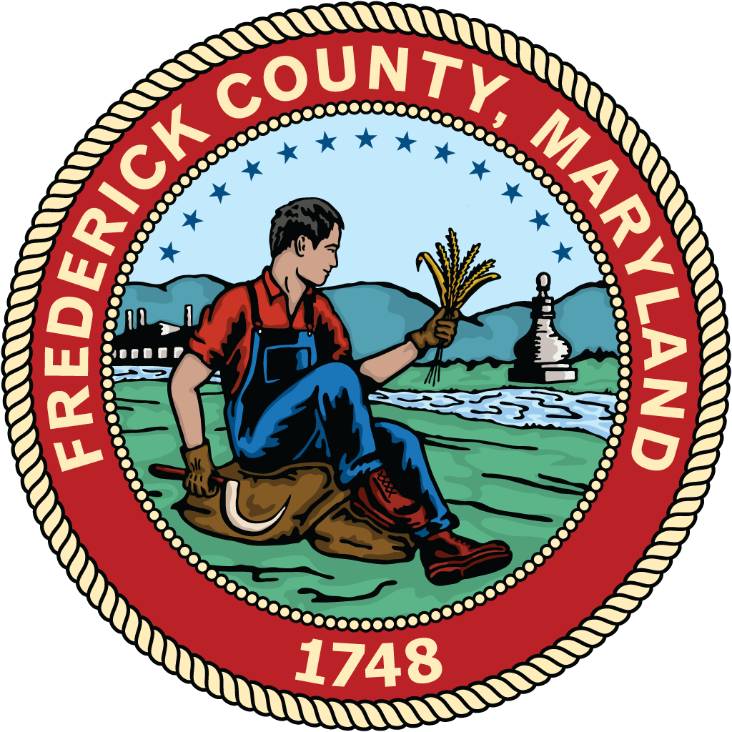
Frederick County
Redistricting Commission

commission Members
Kyle Bostian| Dylan Diggs| John Distel | Flor Garay | Mark Jafari | Bud Otis | James Racheff | Ryan Yamagata | Blaine Young, Jr.

October 25, 2021

The Honorable M.C. Keegan-Ayer
President, Frederick County Council
Winchester Hall
12 East Church Street
Frederick, Maryland 21701

Dear Council President Keegan-Ayer and Council Members,

Enclosed please find the final report and recommendation of the Frederick County Redistricting Commission, as required by Frederick County Resolution No. 21-08, adopted by the County Council on March 30, 2021.

The Frederick County Redistricting Commission was charged with reviewing and making recommendations concerning the Council Districts, ensuring that they are compact, contiguous, substantially equal in population, and have common interests as a result of geography, occupation, history, or existing political boundaries. The Commission held six public meetings between June and October of 2021. A public hearing was held on the proposed redistricting October 21, 2021.

In making their recommendation, the Commission reviewed current Council District boundaries, population results from the 2020 Census, current population by Council District, and recommendations from the Board of Elections of Frederick County.

The Commission is recommending moving Precinct 08-001 (Libertytown) with population size of 2,600 and Precinct 19-001 (Unionville/Linganore Grange Hall) with a population of 1,830 into Council District 5 from Council District 2. This Commission believes this recommendation meets the requirements of compactness, contiguity, and substantial equality of populations in all of the Council Districts,

On behalf of the Commission members, I would like to thank the County Executive and members of the County Council for the opportunity to serve this community in this way.

Sincerely,

Jim Racheff, Chairperson

Frederick County
Redistricting Commission

Report of the Compensation Review Commission October 25, 2021

- AUTHORITY OF COMMISSION

In accordance with the Frederick County Charter, Section 214, the Frederick County Council is required to establish a Redistricting Commission no later than April 1 of the year following each decennial census date to review and make recommendations concerning the Council Districts, ensuring that they are compact, contiguous, substantially equal in population, and have common interests as a result of geography, occupation, history, or existing political boundaries. The Commission is required to submit their recommendation, together with a report explaining it, to the County Council by November 15 of the year following each decennial census date.

Accordingly, this Redistricting Commission was established on March 30, 2021, by Council Resolution 21-08, to review and make recommendations concerning the Council Districts.

- STUDY AND INFORMATION

The Commission was provided with the following items of information to aid in their discussion and ultimate recommendation: current Council District boundaries, population results from the 2020 Census, current County population by Council District, precinct level population data, and recommendations from the Board of Elections of Frederick County.

Since the last decennial census in 2010, the overall County population has grown substantially, from 233,385 to 271,985. The growth within the County is reflective of the growth areas within the County, especially within the Urbana and Linganore areas. The current County Council districts, with the growth of population, currently measure within 3.5% of one another.

- RECOMMENDATIONS

The Commission is recommending moving Precinct 08-001 (Libertytown) with population size of 2,600 and Precinct 19-001 (Unionville/Linganore Grange Hall) with a population of 1,830 into Council District 5 from Council District 2. Precincts 08-001 and 19-001 are geographically similar to District 5, and overall share many common interests with District 5. The following chart reflects the moving of Precincts 08-001 and 19-001, as well as the updated population by Council District as a result of the relocation. This recommendation places all Council Districts within 1.5% of one another. The attached map, exhibit A, reflects the relocation of these two precincts.

 | Current |  | Proposed
District 1 | 56,101 | 20.6% |  | 20.6%
District 2 | 57,447 | 21.1% | 53,017 | 19.5%
District 3 | 56,400 | 20.7% |  | 20.7%
District 4 | 54,155 | 19.9% |  | 19.9%
District 5 | 47,882 | 17.6% | 52,312 | 19.2%

The Commission believes this recommendation meets the requirements that the Council Districts be compact, contiguous, and substantially equal in population while also sharing common interests.

