Commission Members Kyle Bostian, Dylan Diggs, Flor Garay, Mark Jafari, Bud Otis, James Racheff, Ryan Yamagata, John Distel, and were present for the meeting. Commission member Blaine Young, Jr. was absent.

Also present at the meeting were Ragen Cherney, Chief of Staff, County Council; Catherine Keller, Assistant County Attorney; Nancy Luna, Executive Assistant, County Council; and Sarah Grabowski, Executive Assistant, County Council.

Chair Racheff called the meeting to order at 7:00 p.m. at Winchester Hall.

All present recited the Pledge of Allegiance.

Approval of Minutes
The Commission Members voted to approve the Minutes from the September 27, 2021 meeting as written. The Minutes were approved 7-0 (with Flor Garay being absent for the vote).

Discussion of Final Council District Map to Take to Public Hearing
Mr. Racheff confirmed that to change the current adopted map would require the vote of 6 Commission members.
The Commission members confirm that the map voted on during the September 27 meeting is the map the Commission will be sending to the County Council. They agree to discuss possible alternatives.
Mr. Distel suggests moving alternative districts, with the resulting populations being close to equal. The Commission agrees that these suggestions split up municipalities to the extent that the proposed districts do not meet the characteristics as required by the charge of the Commission.

Scheduling of Future Meetings
The Commission agreed to meet on October 21, and October 25. Monday November 1 is another possible meeting date should the Commission need it. The public hearing will be scheduled for the next meeting (Oct 21). The public hearing will be advertised and the public will be able to call in to the meeting.

Adjourn
The meeting adjourned at 7:25 p.m.

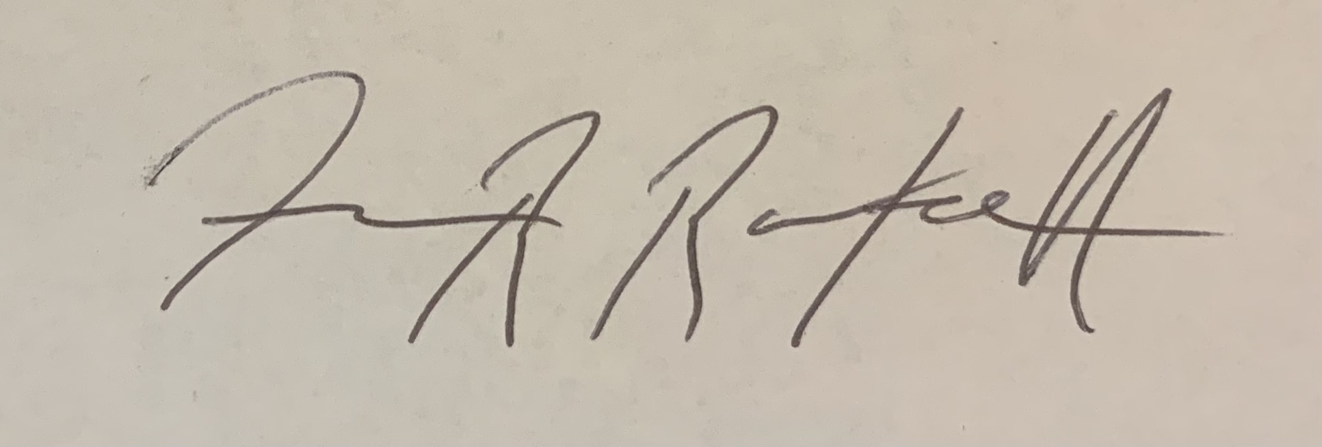

(Approved) James Racheff, Chair

