Commission Members Kyle Bostian, Dylan Diggs, Mark Jafari, Bud Otis, James Racheff, Ryan Yamagata, John Distel, and Blaine Young, Jr. were present for the meeting. Commission Member Flor Garay was absent.

Also present at the meeting were Ragen Cherney, Chief of Staff, County Council; Catherine Keller, Assistant County Attorney; Nancy Luna, Executive Assistant, County Council; and Sarah Grabowski, Executive Assistant, County Council.

Chair Racheff called the meeting to order at 7:00 p.m. at Winchester Hall.

All present recited the Pledge of Allegiance.

Approval of Minutes
The Commission Members voted to approve the Minutes from the October 21, 2021 meeting as written. The Minutes were approved 8-0.

Discussion and Approval of the Frederick County Redistricting Commission’s Final Report on Establishing County Council Districts
Mr. Racheff read the recommendation for the record.
Mr. Otis moved to accept the recommendation, seconded by Mr. Distel. The Commission voted in favor 8-0.

Scheduling of Future Meetings
The Redistricting Commission will present the Final Report to the Frederick County Council on Tuesday, November 9, 2021, at 5:30 PM (Virtual Meeting).

Discussion
Commission members thanked each other, County Council Staff, the Frederick County Board of Elections, and the County Attorneys for their assistance in the effort.

Adjourn
The meeting adjourned at 7:10 p.m.

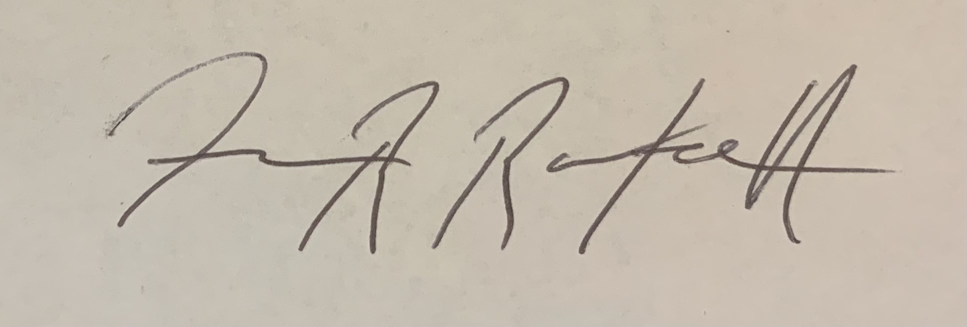

(Approved) James Racheff, Chair

