Commission Members Kyle Bostian, Dylan Diggs, Flor Garay, Mark Jafari, Bud Otis, James Racheff, Ryan Yamagata, John Distel, and Blaine Young, Jr. were present for the meeting.

Also present at the meeting were Ragen Cherney, Chief of Staff, County Council; Catherine Keller, Assistant County Attorney; Nancy Luna, Executive Assistant, County Council; and Sarah Grabowski, Executive Assistant, County Council.

Chair Racheff called the meeting to order at 7:00 p.m. at Winchester Hall.

All present recited the Pledge of Allegiance.

Approval of Minutes
The Commission Members voted to approve the Minutes from the October 7, 2021 meeting as written. The Minutes were approved 9-0.

Public Comment
None.

Scheduling of Future Meetings
The Commission will meet on October 25 at 7pm. At this meeting, the Commission will confirm their final report to be presented to the County Council on November 9.

Adjourn
The meeting adjourned at 7:15 p.m.

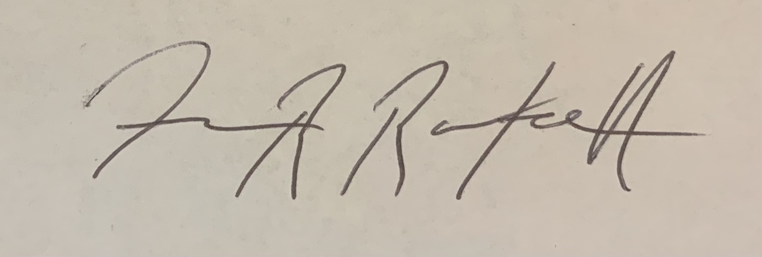

(Approved) James Racheff, Chair

