News Release

FOR IMMEDIATE RELEASE CONTACT: Chaslyn Derexson
July 21, 2023 Project Manager
(301) 600-1585

Bridge Replacement on Old Mill Road

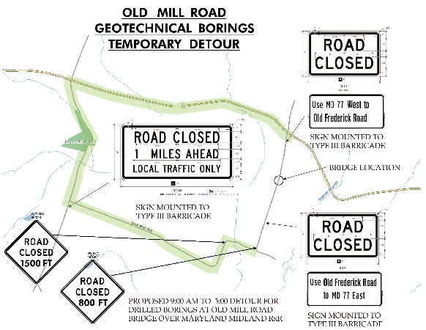
FREDERICK, Md. —The Frederick County Office of Transportation Engineering, is scheduled to start a project on the bridge at Old Mill Road on or about July 31, 2023.

A daytime detour will be put in place to allow work vehicles to park on the road. The detour for local traffic will be clearly marked and indicate the use of MD 77 West to Old Frederick Road to minimize disruptions to roadway traffic. Completion time for the project has not been announced.

For further information on the project, please contact Chaslyn Derexson using cderexson@FrederickCountyMD.gov or by phone at (301) 600-1585.

###

