News Release

FOR IMMEDIATE RELEASE: CONTACT: Mark Schweitzer
September 20, 2023 Division Director, 301-600-2296
County Encourages Water Conservation During Drought Watch
FREDERICK, MD - Frederick County Division of Water and Sewer Utilities is encouraging their customers to voluntarily reduce their water usage by 10-15%. On September 20, 2023, the Maryland Department of Environment (MDE) upgraded a drought watch issued earlier this summer to a drought warning.
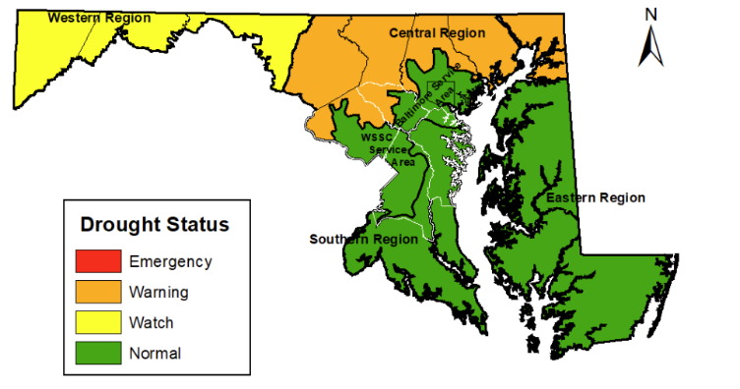
The majority of our customers rely upon the Potomac River for drinking water, the County water systems which rely upon groundwater have been adversely affected due to the lack of precipitation. Those systems would include Bradford Estates, Cambridge Farms, Copperfield, Fountaindale, Knolls of Windsor, Libertytown Apartments, Libertytown East, Sam Hill Estates, and White Rock.
No mandatory water use restrictions have been issued at this time, but residents and businesses that are connected to a Frederick County water supply are encouraged to take steps to reduce their personal water usage. You can help to ease the burden on our water supply by doing a few simple things and save money in the process.
● Avoid watering lawns and gardens
● Avoid washing cars, boats, or other outdoor equipment
● Avoid using water to clean driveways, sidewalks, parking areas, and patios
● Do not let the faucet flow unnecessarily while brushing your teeth or shaving
● Only Run the dishwasher and washing machine when full loads are available

Additional water conservation tips can be found on MDE’s Water Conservation webpage.

For further information or questions, contact Division Director Mark Schweitzer at 301-600-2296 or via e-mail at MSchweitzer@FrederickCountyMD.gov.

###

